**Intelligent Admission: The Future of University Making with Machine Learining**

|  |  |  |  |  |  |
| --- | --- | --- | --- | --- | --- |
| **CHAPTER** | | **TITLE** | | **PAGE.NO** | |
| **1** | | **INRODUCTION**  **1.OVERVIEW**  **2.PURPOSE** | |  | |
| **2** | | **PROBLEM DEFINITION &**  **DESIGN THINKING**  **2.1 EMPATHY MAP**  **2.2 IDEATION & BRAINSTOMING MAP** | |  | |
| **3** | | **RESULT** | |  | |
| **4** | | **ADVANTAGES & DISADVANTAGES** | |  | |
| **5** | | **APPLICATION** | |  | |
| **6** | | **CONCLUSION** | |  | |
| **7** | | **FUTURE SCOPE** | |  | |
| **8** | **APPENDIX**  **8.1 SOURCE CODE** | |  | |

CHAPTER 1

1. INTRODUCTION

1.1 OVERVIEW

The project (Intelligent Admission: The future of university

decision making with machine learning) to build a machine learning

model that can predict In recent years, the use of machine learning in the

admissions process for universities has become an increasingly popular

topic. With the vast amounts of data that universities collect on

applicants, machine learning algorithms have the potential to analyze

this data and make more informed decisions about which students to

admit. This approach, known as intelligent admissions, has the potential

to improve the fairness, efficiency, and effectiveness of the admissions

process.

By using machine learning algorithms, universities can identify patterns

and trends in data that might not be immediately apparent to human

admissions officers. This can help to eliminate biases that might exist in

the current admissions process and allow universities to consider a wider

range of factors when making decisions about which applicants to admit.

1.1 PURPOSE

The purpose of this project is to develop a machine learning model

the purpose of the "Intelligent Admissions: The Future of University

Decision Making with Machine Learning" project is to explore the

potential benefits of using machine learning algorithms in the

admissions process for universities. The project aims to build a machine

learning model that can analyze the vast amounts of data collected by

universities on applicants and make more informed decisions about

which students to admit.

The project seeks to address some of the limitations of the current

admissions process by eliminating biases that might exist and allowing

universities to consider a wider range of factors when making decisions

about admissions. Additionally, the project aims to improve the

efficiency and effectiveness of the admissions process by automating

certain aspects of the process, reducing the time and resources needed to

make admissions decisions.

Overall, the purpose of the project is to explore how machine learning

can be used to create a fairer, more efficient, and more effective

admissions process for universities.

CHAPTER 2

2. PROBLEM DEFINITION & DESIGN THINKING

2.1 PROBLEM DEFINITION:

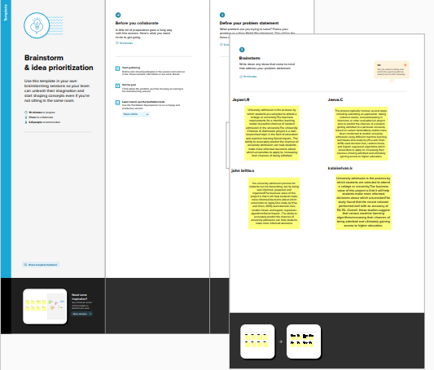

2.2 IDEATION & BRAINSTOMING MAP:

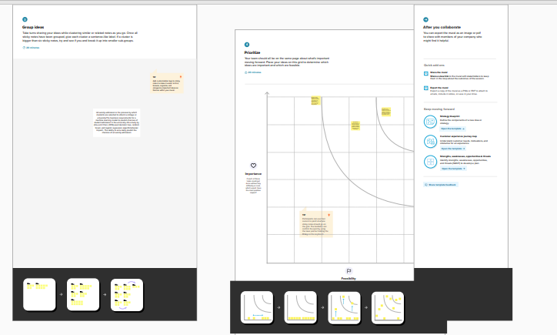

CHAPTER 3

3. RESULT

Result 1:

• Import all the tools we need.

• All needed tools import successful.

Result 2:

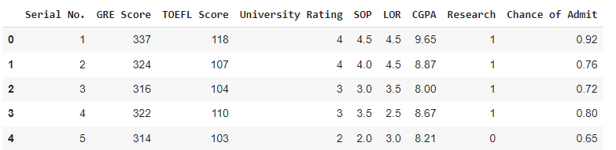

Result 3:

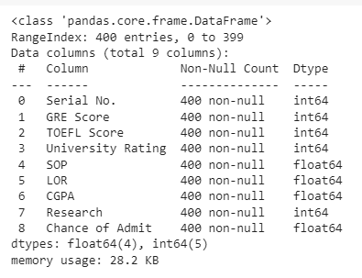

Result 4:

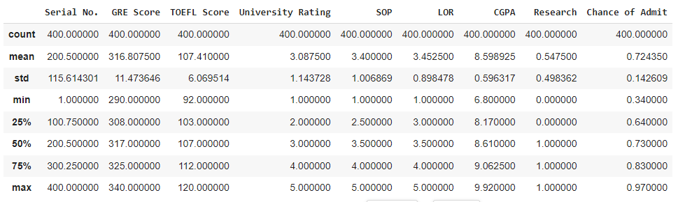

Result 5:

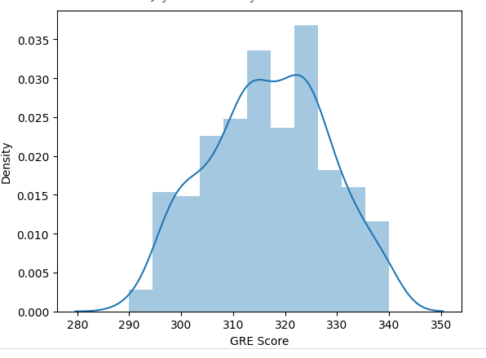

Result 6:

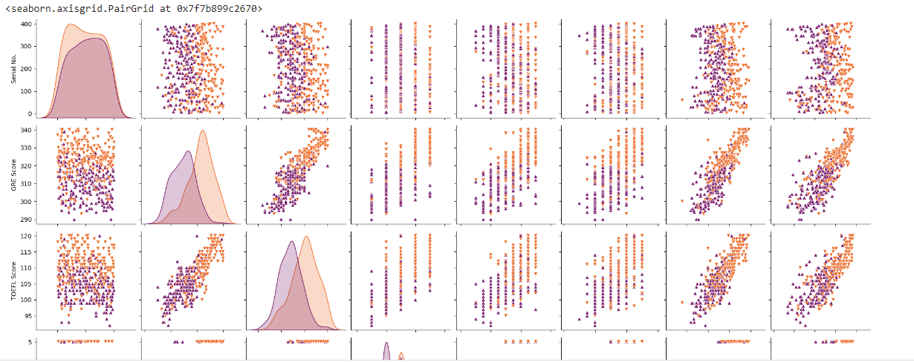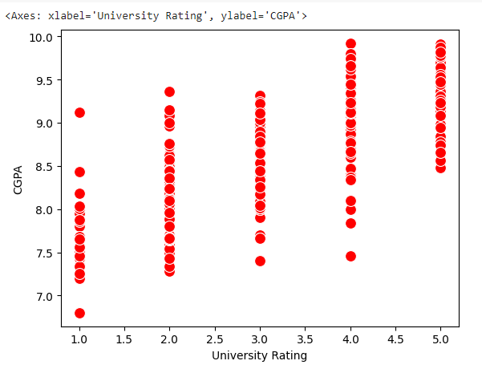

Result 8:

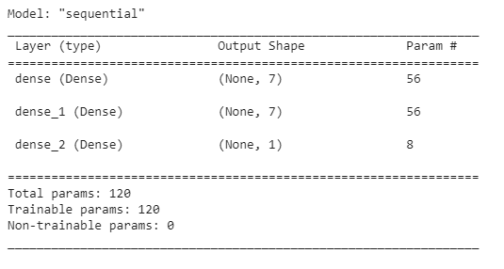

4. ADVANTAGES & DISADVANTAGES

ADVANTAGES:

• Efficient and Accurate: Intelligent admission can process large

volumes of data quickly and accurately, helping universities to

make more informed decisions and reducing of risk of human

error.

• Machine learning algorithms can help eliminates biases and

discrimination in the admission process, ensuring that candidates

are based on their merit rather than their demographic

characteristics.

• By admitting the most qualified candidates, University can

improve students overcomes, such as graduation employment

prospects.

By automating the admission process, University can save time and

money on administrative tasks, freeing up resources to invest in other

areas

DISADVANTAGES:

• Intelligent admission relies solely on data and algorithms to make

admission decision, which can lead to a lack of personal touch and

a failure to consider intangible factors that may be important

process.

• Machine learning algorithms require large amounts of data to train

and make accurate predictions, which may not always be available

or accessible for some university.

• Although machine learning algorithms can help eliminate bias and

discrimination, they can also perpetuate it if the data used o train

them is biased or incomplete.

• Machine learning algorithms can be complex and difficult to

understand, which may make it challenging for university to

explain admission decisions to students and other stakeholders.

CHAPTER 5

5. APPLICATIONS

Machine learning is a subfield of artificial intelligence that

involves the use of algorithms and statistical models to analyze data and

make predictions. The application of machine learning techniques in

university admissions can streamline the process, reduce bias, and

improve the accuracy of decision-making.

Here are some potential applications of machine learning in university

admissions:

• Predictive modeling: Machine learning algorithms can be

used to develop predictive models that analyze various

factors such as grades, test scores, extracurricular activities,

and personal statements. These models can predict a student's

likelihood of success at the university and help admissions

officers make informed decisions.

• Bias reduction: Machine learning algorithms can reduce the

impact of unconscious bias by removing identifying

information such as gender, race, and ethnicity from

applications. This can help ensure that admissions decisions

are based solely on merit.

• Data analysis: Machine learning algorithms can analyze large

volumes of data to identify patterns and trends. This can help

admissions officers identify the characteristics of successful

students and make informed decisions based on data-driven

insights.

• Personalization: Machine learning algorithms can be used to

personalize the admissions process by tailoring questions and

feedback to individual applicants. This can help applicants

feel more engaged with the process and improve their overall

experience.

• Fraud detection: Machine learning algorithms can be used to

detect fraudulent applications by analyzing patterns and

anomalies in the data. This can help prevent admissions fraud

and ensure the integrity of the admissions process.

Overall, the application of machine learning in university

admissions has the potential to revolutionize the way universities make

admissions decisions. By streamlining the process, reducing bias, and

improving the accuracy of decision-making, machine learning can help

universities select the best candidates and build a more diverse and

successful student body

CHAPTER 6

6. CONCLUSION

Every year millions of students apply to universities to begin their

educational life. Most of them don’t have proper resources, prior

knowledge and are not cautions, which in turn created a lot problem as

applying to the wrong university/college, which further wastes their

time, money and energy.

With the help of our project, we have tried to help out such

students who are finding difficulty in finding the right university for

them. It is very important that a candidate should apply to colleges that

he has a good chance of getting into, instead of applying to colleges that

they may never get into. This will help in reduction of cost as students

will be applying to only those university that they are highly likely to get

into this will help in reduction to get into.

Our prepared models work to a satisfactory level of accuracy and

may be of great assistance to such people. This is a project with good

future, especially of our age group who want to pursue their education in

their dream college.

CHAPTER 7

7. FUTURE SCOPE

Here are some potential enhancements that can be made in the

future for the intelligent admission classification model:

• Feature selection and engineering: While the current model uses all

the features available in the dataset, further analysis can be done to

identify the most important features for accurate classification.

Additionally, new features can be engineered from the existing

ones to improve the model's performance.

• Hyper parameter tuning: The current model uses default hyper

parameters for the decision tree classifier, but more advanced

techniques such as grid search or random search can be used to

optimize the hyper parameters for better performance.

• Ensemble learning: Ensemble learning techniques such as random

forests or gradient boosting can be used to combine multiple

decision tree classifiers to improve the overall accuracy and

generalization of the model.

• Improved dataset: The current dataset only contains 200 samples,

and collecting more data can help in building a more robust and

accurate model.

Overall, there are many potential enhancements that can be made to the

classification model, and future research can focus on exploring these

areas to improve the accuracy and applicability of the model in settings.

CHAPTER 8

8. APPENDIX

8.1 SOURCE CODE

#read_csv is a pandas function to read csv files

Data = pd.read_csv('Admission_Predict.csv')

Data.head()

Data.info()

Data.isnull().any()

Data.describe()

sns.distplot(Data['GRE Score'])

sns.pairplot(data=Data,hue='Research',markers=["^","v"],palette='inferno')

sns.scatterplot(x='University Rating',y='CGPA',data=Data,color='Red',s=100)

model=keras.Sequential()

model.add(Dense(7,activation ='relu',input_dim=7))

model.add(Dense(7,activation='relu'))

model.add(Dense(1,activation='linear'))

model.summary()